At first I had ROLE_USER assigned to this Dummy user but as you requested I added another role which I also updated the directory where I bulk uploaded the initial files.
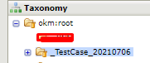
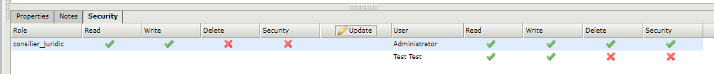

Login as Dummy user ( after making all changes above):


