Replication steps
The following details are replicated into a OpenKM 6.3 CE test environment.
1. Login as 'Administrator' user:
2. Create a new directory to serve as root for the immediate uploads
3. Default permissions for directory '_TestCase_20210706'
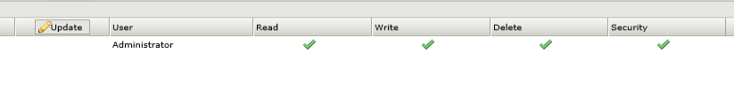
4. Files uploaded from internal share into OpenKM application using 'Bulk Uploader'
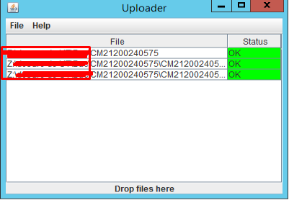
5. Checks made from the OpenKM application to see if the documents were uploaded succesfully
Status: ok, the files are accessible and readable/modifiable.
6. Using a dummy user to try and grant access and read the files afterwards
username: testt
7. Grant permissions read/write for user 'Test Test' on root directory '_TestCase_20210706':
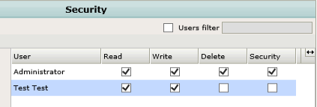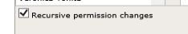
Final overview:
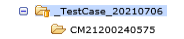
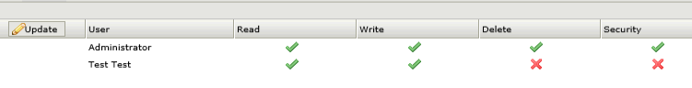

8. Login as 'Test Test' and check the files uploaded earlier:
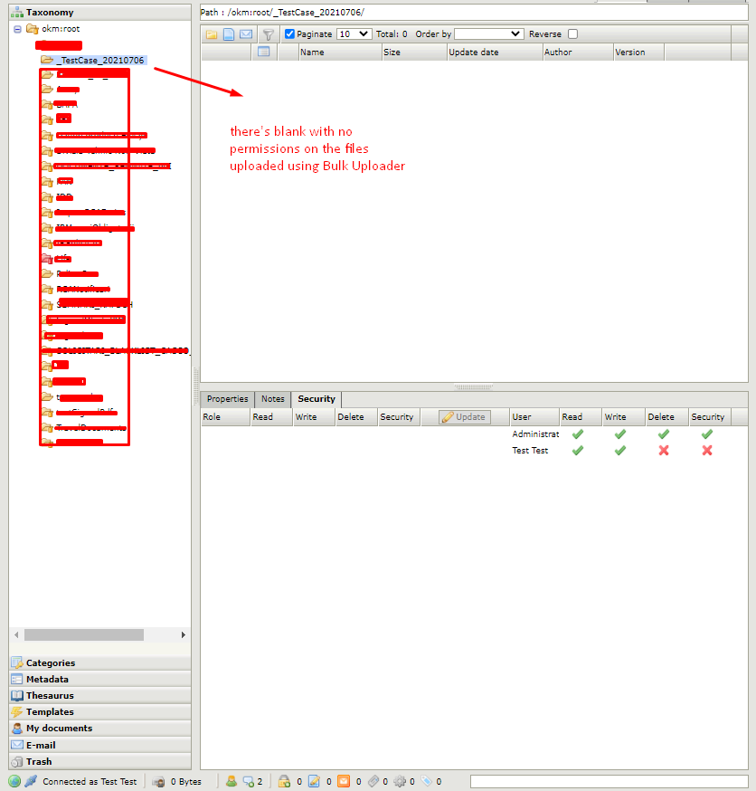

Like I mentioned in the forum thread whatever possibilities I would try and permission the recent uploaded files it seems that the files within the subdirectories aren't available. I can just permission the directories/subdirectories but not the files itself.

